
Bishop Wilson C of E Primary School
7th February 2018
Dear Parents,
Maths Quiz Final
We recently sent a team of 4 Year 6 children to an Inter-Primary Maths Quiz run by Neston High School in conjunction with Liverpool University. We are very pleased to inform you that our team has made it through to final which is being held on Tuesday 27th February at The Civic Hall in Ellesmere Port.
Funding has been arranged to transport all our Year 6 children to go along and support their team at this final. After an early lunch, all our Year 6s will travel to The Civic Hall in Ellesmere Port and will return for the end of the school day. All children are expected to wear full school uniform for this visit.
Please note that the partnership may wish to take photographs of the children for publicity purposes. Therefore in agreeing for your child to take part, you will also need to consent to this condition.
If you would like your child to take part in this event then please complete the attached slip below and Form C attached.
Kind regards
Mrs S. Roberts






Maths Quiz Final – 27th February 2018
Name of child _____________________________________________________________________
I give / do not give permission for my child to take part in this event.
I consent to photographs being taken of my child during the afternoon for publicity purposes

Signed ______________________________________________________ Parent/Carer
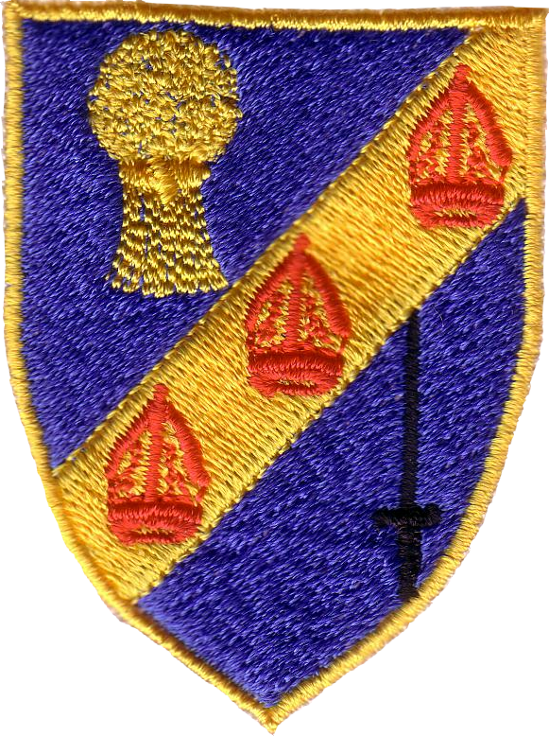
BISHOP WILSON C of E SCHOOL

