# PE Pupil Voice Survey Report – 2024-2025

Total responses: 42 pupils from Years 3 to 6

* Year 3: 4 pupils
* Year 4: 12 pupils
* Year 5: 15 pupils
* Year 6: 11 pupils

This report summarises the responses of Bishop Wilson CE school children to the PE Pupil Voice Survey. The aim is to capture pupil enjoyment, understanding, confidence and participation in PE and physical activity opportunities across the school.

## Enjoyment of PE

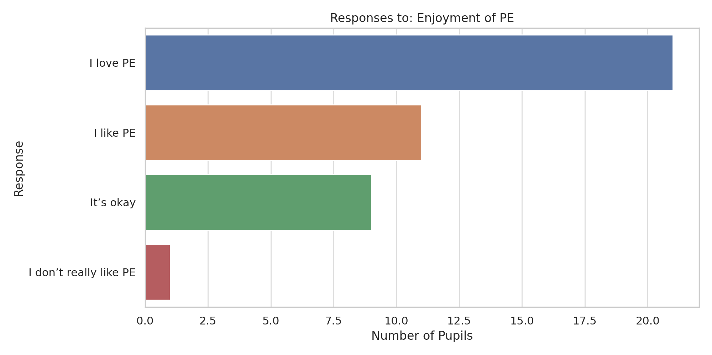

## Understand Learning

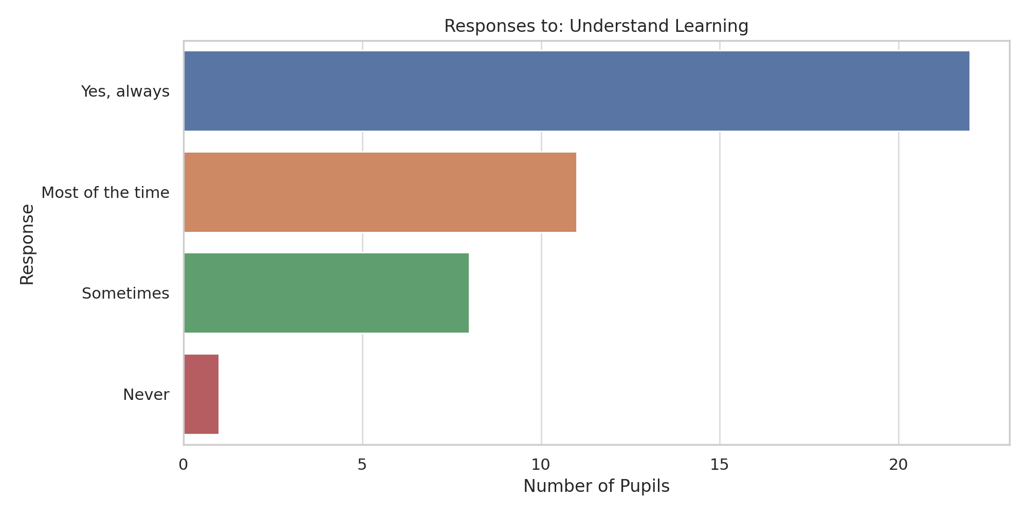

## Confidence Gained

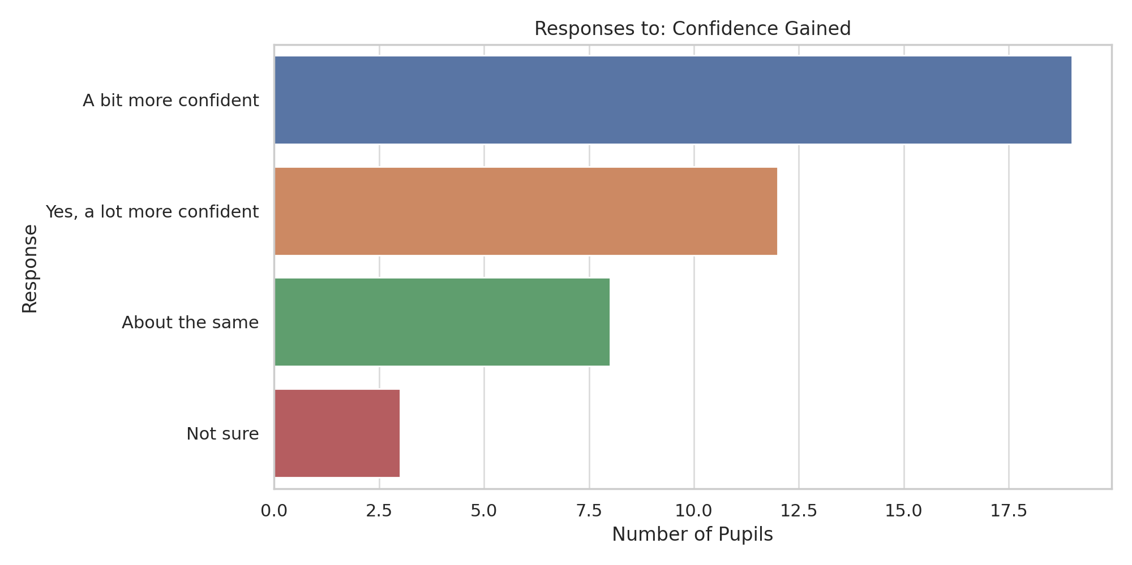

## Lunchtime Activity

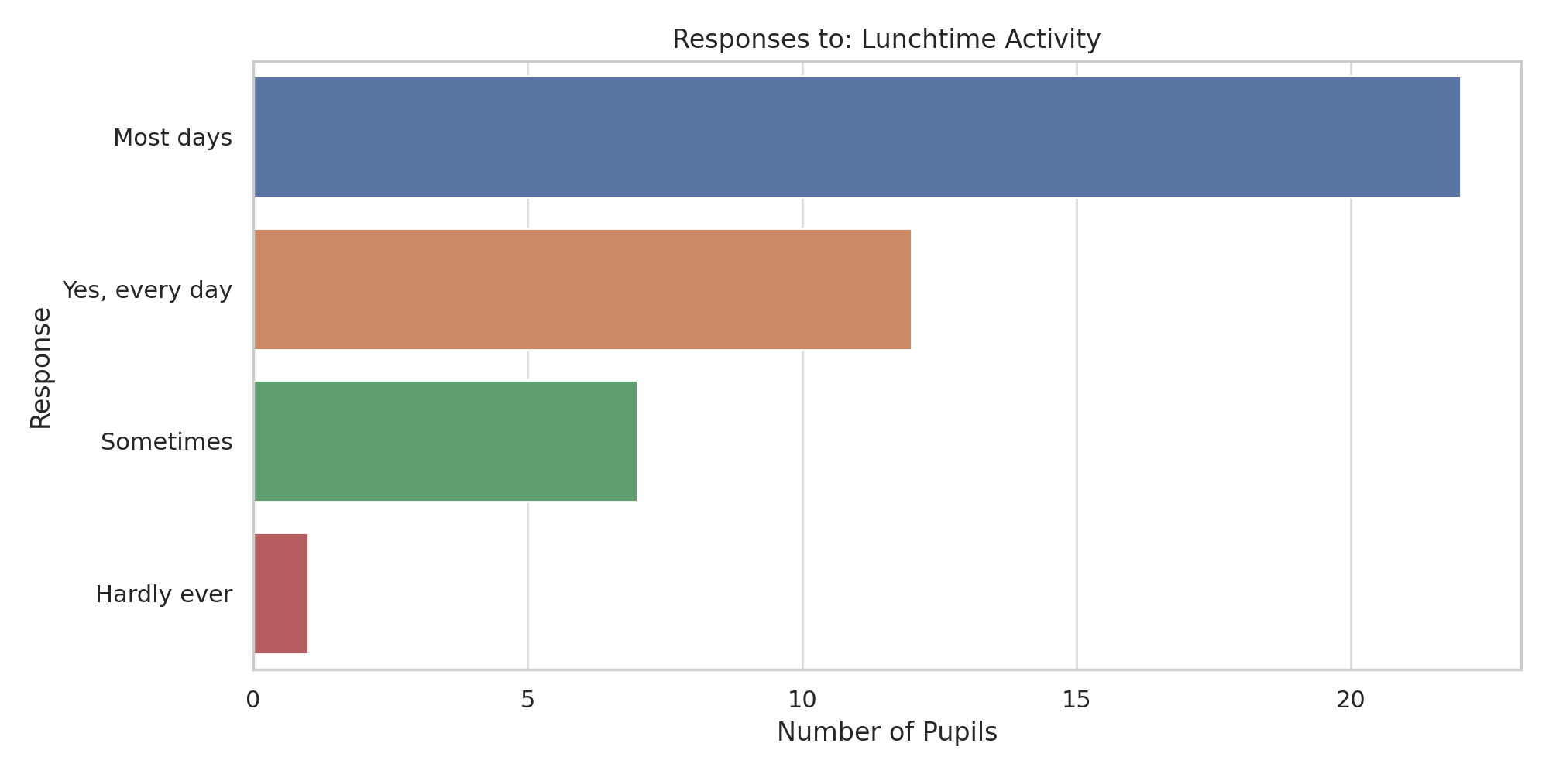

## Club Participation

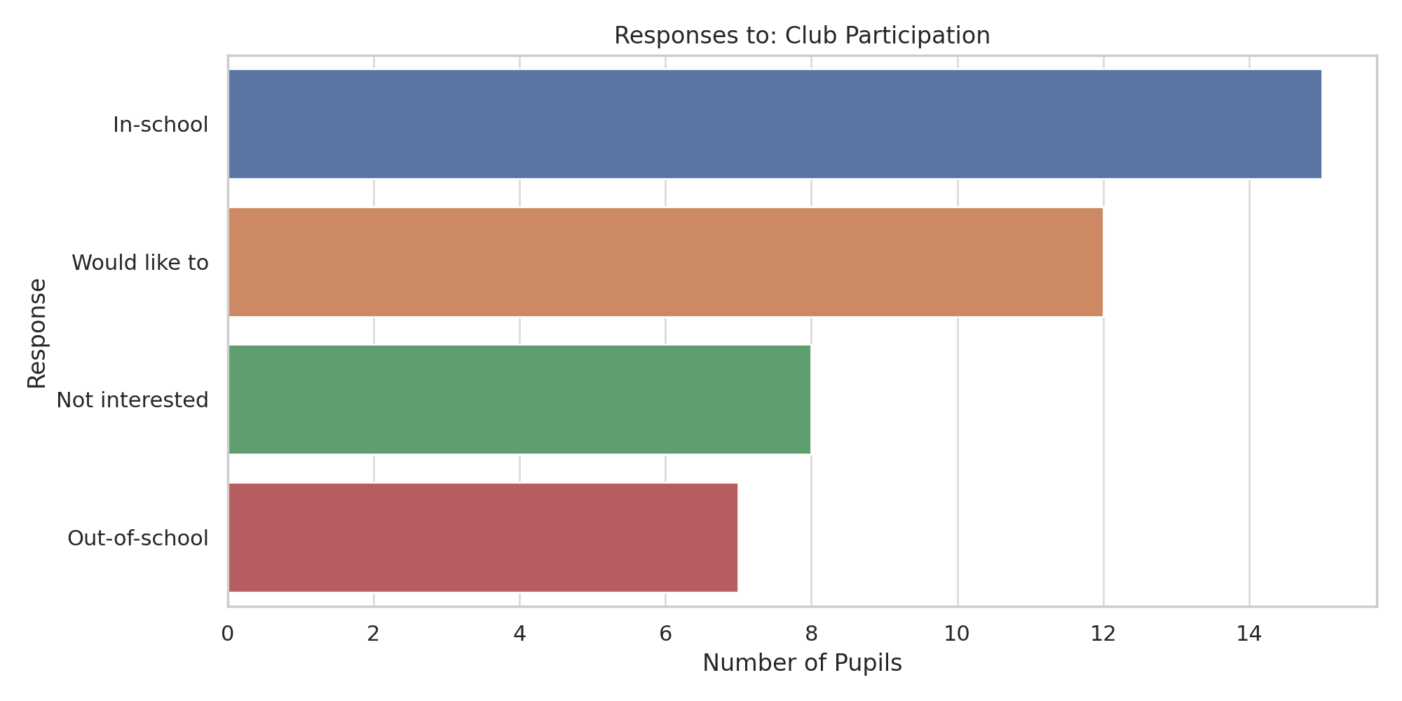

## Feel Included

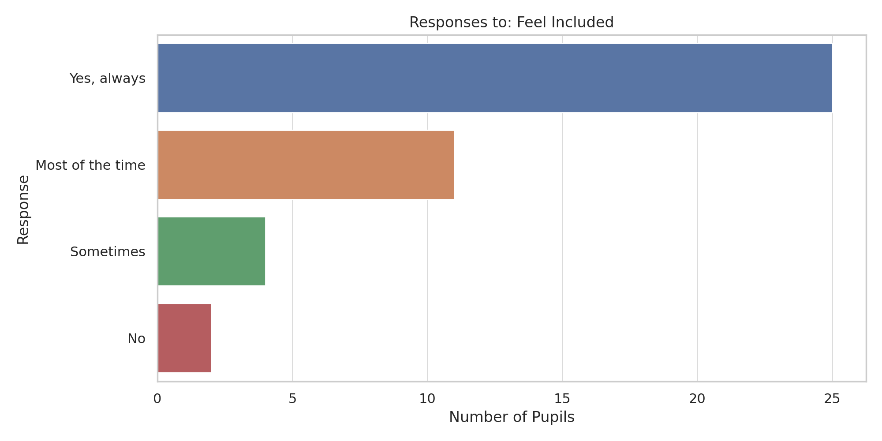

## Wants to Lead

